**22AIE204 Introduction to Networks**

**Labsheet - 4**

**Analyzing the network performance for internet applications**

Name: **Girish S** Roll No: **AM.EN.U4AIE22044**

**______________________________________________________________________________________________________**

**Problem 1**

**On linux you can use the command**

**traceroute www.targethost.com**

**and in the Windows command prompt you can use**

**tracert www.targethost.com**

**In either case, you will get three delay measurements. For those three measurements you can calculate the mean and standard deviation. Repeat the experiment at different times of the day and comment on any changes.**

**Morning 8 am:**

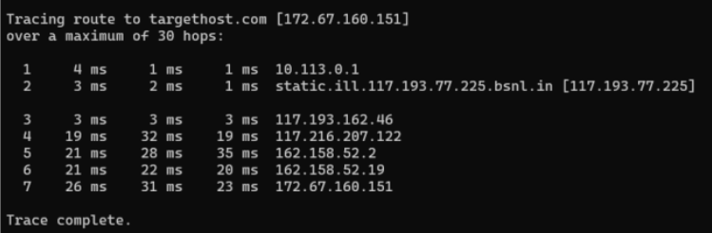**Mean:** 26.67 ms

**Standard Deviation:** 4.0414 ms

**Afternoon 1 pm:**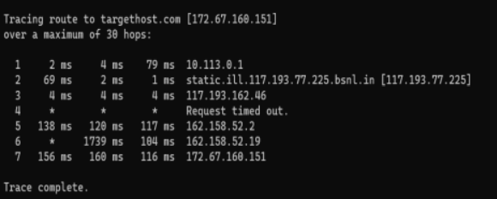

**Mean:** 144 ms

**Standard Deviation:** 24.3310 ms

**Night 10 pm:**

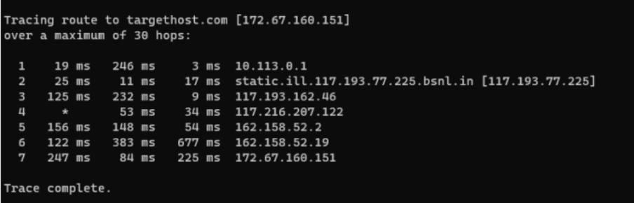

**Mean:** 185.3333 ms

**Standard Deviation:** 88.4439 ms

The average duration appears to be significantly extended during nighttime hours and reduced during the morning. This trend implies that decreased demand in the morning results in faster response times, while heightened demand at night contributes to increased delays.

**Problem 2**

Analyze the different aspects of the HTTP protocol in the Wireshark: the basic GET/reply interaction, HTTP message formats, retrieving HTML files with embedded URLs, persistent or nonpersistent connections, and HTTP authentication/security.

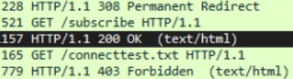

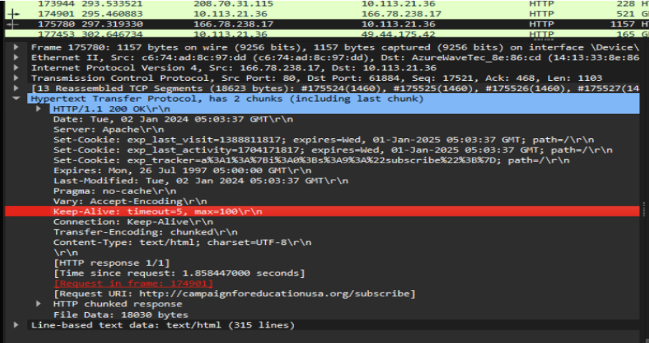

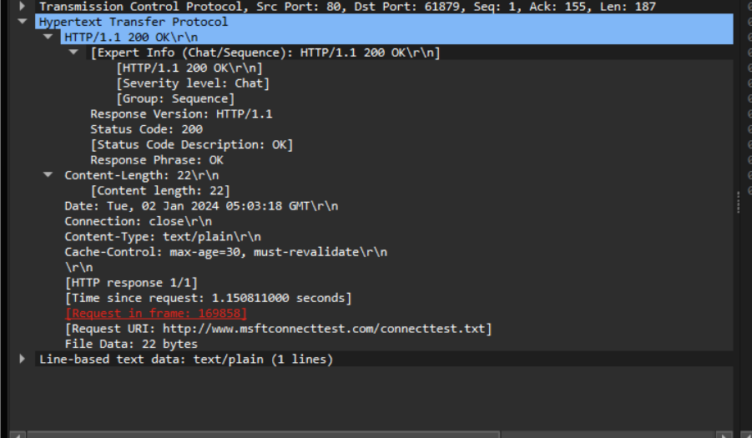

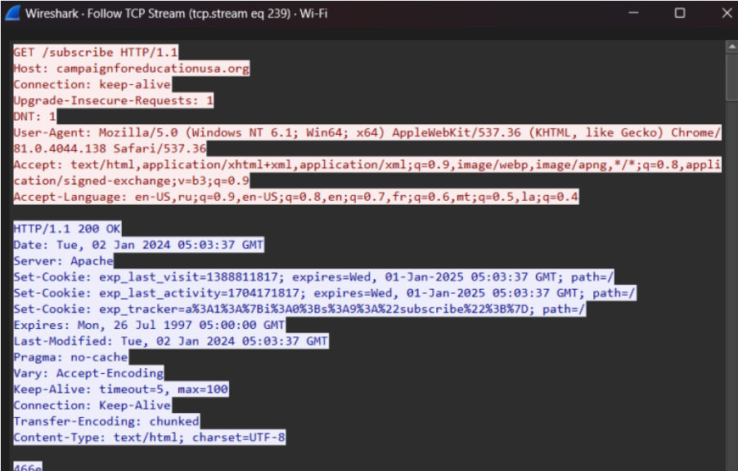

The above figure illustrates an HTTP packet TCP interaction, demonstrating the exchange between a GET request and a 200 OK response. It also displays the message formats for both the request and response, consistently revealing the HTTP version each time. It also contains a status code and request type.

**Problem 3**

Download the open source startrinity software for continuous internet speed test tool - [Continuous internet speed test tool (startrinity.com)](http://startrinity.com/InternetQuality/ContinuousBandwidthTester.aspx)

Select any of the internet applications that takes long time to evaluate. Analyze for packet loss, delays in accessing the internet applications for a long time based on differences in the internet speed.

Example: Video conferencing services –gmeet, zoom, teams, Video streaming services – YouTube, gaming applications etc.

Start the continuity speed test and capture the frames in Wireshark while you are using the selected internet application for 10 to 15 minutes. Analyze the mean and standard deviations of packet loss, delay with respect to changing internet speed from the csv file output of startrinity and analyze the throughput in wireshark.

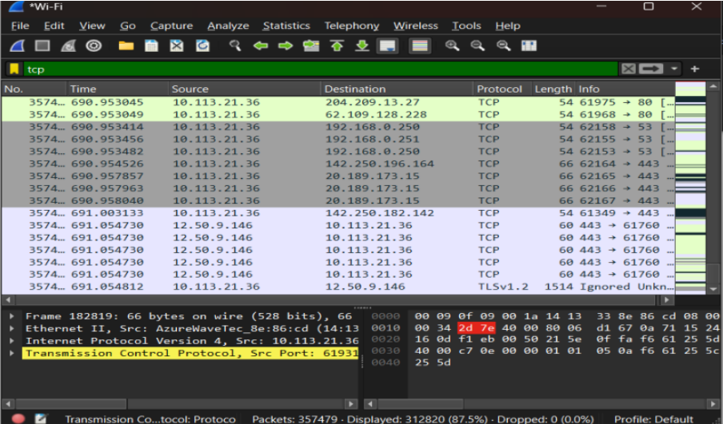

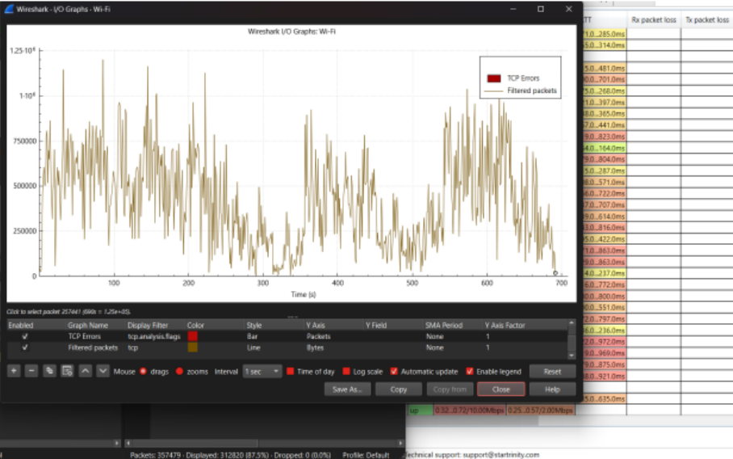

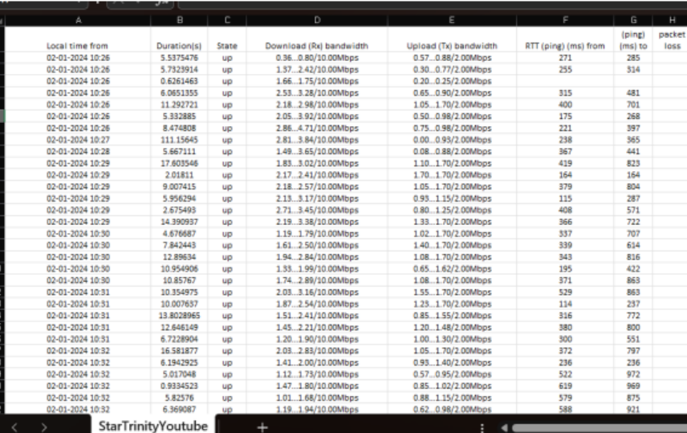

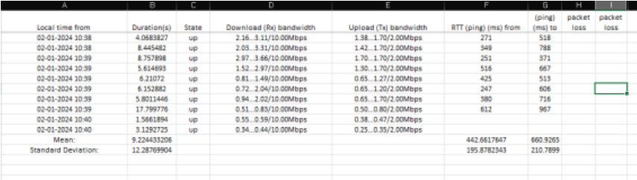

The CSV file output from StarTrinity had no packet loss. The least throughput occurred at the 290 seconds (781 bytes) and the maximum throughput at 531 seconds (1.037 * 10^6 bytes) The mean and standard deviation can be seen from the screenshots.